
RAMAIAH
Institute of Technology
USN | 1 | M | S

(Autonomous Institute, Affiliated to VTU)
(Approved by AICTE, New Delhi & Govt. of Karnataka) Accredited by NBA & NAAC with ‘A’ Grade

SEMESTER END EXAMINATIONS – JULY / AUGUST 2021
Program | : | B.E. : Common to all Programs | Semester | : | I / II
Course Name | : | Basic Electrical Engineering | Max. Marks | : | 100
Course Code | : | EE15/EE25 | Duration | : | 3 Hrs

Instructions to the Candidates:
- Answer one full question from each unit

 |  | UNIT- I
1. | a) | With a neat diagram explain the working principle of thermal power plant. | CO1 | (07)
 | b) | Explain the different types of tariffs for electrical energy consumption. | CO1 | (08)
 | c) | Mention the requirements of grid interconnection. | CO1 | (05)
2. | a) | What are the required conditions for interconnecting wind energy source to the electrical grid? | CO1 | (03)
 | b) | Define load. Explain the different types of load based on the Nature of the load. | CO1 | (07)
 | c) | Define power factor. What is the unit of Power factor? | CO1 | (04)
 | d) | What are the advantages and disadvantages of transmission power at high voltage? | CO1 | (06)
 |  | UNIT – II
3. | a) | Two devices rated 60W, 110V and 40W, 110V are connected in series across a 110V dc supply. Find the actual power consumed by each of the load and the total current drawn from the supply. If the loads were connected in parallel across the same supply, what would be the individual powers taken by each of the loads and the total power taken from the source? | CO2 | (08)
 | b) | With a neat diagram, derive an expression for the relationship between voltage and current in a pure capacitive circuit and show that the average power dissipated is zero. Draw the waveforms of Voltage, Current and Power. | CO2 | (06)
 | c) | A coil of power factor 0.6 is in series with a 100 µF capacitor. When it is connected to a 230V, 50Hz ac supply, the potential difference across the coil is equal to the potential difference across the capacitor. Calculate the resistance and inductance of the coil, and power consumed by the coil. | CO2 | (06)
4. | a) | Using Kirchhoff’s laws find the current through 2Ω resistance in the network shown in Fig.4(a).  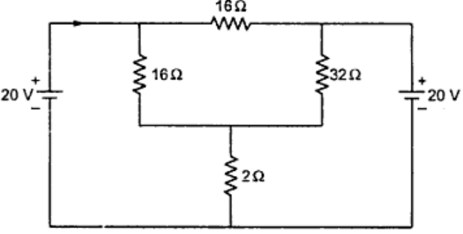  Fig. 4(a) | CO2 | (06)
 | b) | Show that current in a series RL circuit lags the supply voltage with an appropriate vector diagram. Hence, derive an expression for power consumed in the circuit and also draw the waveforms of Voltage, Current and Power. | CO2 | (07)
 | c) | Two circuits with impedances Z₁= (10+j15) Ω and Z₂ = (6-j8) Ω are connected in parallel. If the supply current is 20 A, what will be the power dissipated in each branch. | CO2 | (07)
 |  | UNIT – III
5. | a) | An iron rod 2 cm in diameter and 20 cm long is bent into a closed ring and is wound with 3000 turns of wire. When a current of 0.5 A is passed through this coil, the flux density in the coil is 0.5 Wb/m². Assuming that all the flux is linked with every turn of the coil, Find: (i) the inductance of the coil (ii) the voltage developed across the coil if the flux in the iron falls to 10% of its former value in 0.001 second. | CO3 | (06)
 | b) | An 8 pole armature of a DC generator is wound with 480 conductors. The magnetic flux and the speed are such that the average emf generated in each conductor is 2.2 V and each conductor is capable of carrying a full load current of 100 amps. Calculate the terminal Voltage on no load, the output current on full load and the total power generated on full load when the armature is (i) lap connected (ii) wave connected. | CO3 | (06)
 | c) | Enumerate various losses occurring in a transformer and suggest methods to reduce them. | CO3 | (04)
 | d) | Explain the principle of operation of a DC motor. | CO3 | (04)
6. | a) | A 4 pole, 220V, lap connected D.C. shunt motor has 36 slots, each slot containing 16 conductors. It draws 40A from the supply. The field resistance and armature resistances are 110Ω and 0.1Ω respectively. The motor develops a shaft output power of 6kW. The flux per pole is 40 mWb. Calculate i) speed ii) torque developed by the armature and iii) shaft torque | CO3 | (07)
 | b) | How are DC motors classified? Explain each with relevant sketches and their expression for back emf. | CO3 | (08)
 | c) | The voltage ratio of a 50 Hz, 25 kVA single phase transformer is 6000/250 volts. If the maximum flux in the core is 0.05 Wb, determine the number of turns on each winding. Calculate full load primary and secondary currents. | CO3 | (05)
 |  | UNIT – IV
7. | a) | Explain the concept of Rotating Magnetic Field. | CO4 | (06)
 | b) | Obtain the relation between phase and line quantities in a balanced delta connected system. | CO4 | (06)
 | c) | A 10-pole 3φ alternator is coupled to an engine running at 960rpm. It supplies an Induction Motor which has a full load speed of 1540rpm. Find the percentage slip and the number of poles of the motor. | CO4 | (08)
8. | a) | Can an induction motor run at synchronous speed? Justify your answer. | CO4 | (06)
 | b) | Find the number of armature conductors in series per phase required for the armature of a 3φ, 10-pole, 60Hz alternator with 120 slots. The winding is to be star-connected to give a line voltage of 12000V. The flux per pole is about 0.3Wb. | CO4 | (06)
 | c) | A three-phase delta connected load consumes a power of 200kW taking a lagging current of 200A at a line Voltage of 1100V, 50Hz. Find the parameters of each phase. What would be the power consumed if the load were connected in star? | CO4 | (08)
 |  | UNIT – V
9. | a) | Why electrical earthing is required? Briefly discuss. | CO5 | (06)
 | b) | Explain the working principle of stepper motor. Using a diagram, describe the construction of a variable reluctance stepper motor. | CO4 | (08)
 | c) | Write short notes on various electrical hazards. | CO5 | (06)
10. | a) | Mention the application of a fuse in electrical circuit. Briefly discuss about the different types of fuses. | CO5 | (06)
 | b) | Describe the construction of a brushless dc motor and mention its applications. | CO4 | (08)
 | c) | Illustrate the working of a miniature circuit breaker (MCB). | CO5 | (06)

****************

